Architecture Vision
Citizen Services Mobile Application

Version 0.1
For
<CLIENT>

Contents
1 Introduction 5
1.1 Purpose 5
1.2 Scope 5
1.3 Definitions 5
1.4 References 6
1.5 Documentation Roadmap 6
2 Executive Summary 8
2.1 Key Decisions 8
2.2 Key Risks and Open Issues 8
3 Architectural Drivers 9
3.1 Business Case 9
3.1.1 Business Goals 10
3.1.2 Major Features 10
3.2 Use Case Model 11
3.2.1 Use Case View <View Name> 11
3.3 Design Constraints 12
3.4 Quality Attribute Scenarios 13
4 Solution Architecture 15
4.1 Big Picture 15
4.1.1 Solution Context 15
4.1.2 Solution Decomposition 16
4.2 Design Concerns 18
4.3 Development Technology Stack 19
4.3.1 Development Languages, Frameworks, and Libraries 19
4.3.2 Development Tools 19
4.3.3 External Integration Points 20
5 Implementation Roadmap 21
5.1 Implementation Deliverables 21
5.2 Implementation Milestones 21
5.3 Estimate 22
5.3.1 Assumptions and Limitations 22
5.3.2 Estimate 22
5.4 Team 22
5.4.1 Team Skillset 23
5.4.2 Team Structure 23

Revision History
Date | Version | Description | Author
 | <x.x> | <details> | <name>
 | <x.x> | Approved | <name>

Introduction

Purpose
This Architecture Vision elicits the significant architecture drivers such as business, functional, nonfunctional requirements and constraints, defines architecture, and develops a roadmap for Single Entry implementation. The document is intended as a primary technical guidance into solution implementation for the development team.
The solution architecture is designed following the guiding principles outlined in Appendix A – Architecture Design Methodology.

Scope
The document describes the proposed Single Entry architecture towards development of the solution that will satisfy business, functional, non-functional requirements and constraints provided by the Client. This Architecture Vision covers the following information:
- Significant architectural drivers for the Solution
- Proposed software architecture of the solution based on these drivers
- Technology stack and environment definitions
- Operations specific perspectives
- Development road map and high level estimates for effort, team size and skill sets.

Definitions
The Definitions section lists the acronyms and terms used in this document which might possess lesser familiarity or double meaning to the reader.
(Fill the table if you have definitions)
# | Term | Definition

References
The References section provides a complete list of all the documents referenced elsewhere in this document.
(Fill the table if you have references)
# | Version | Date | Document Name | Published by
 | <x.x> | <mm/dd/yyyy> | <Document Name> | <Publishing Organization>

Documentation Roadmap
This section guides into the Architecture Vision document structure to help find the information of interest.
- Executive Summary speaks about the proposed architecture on the highest level and covers:
  - Key Decisions about the architectural and operational choices made for the solution
  - Key Risks and Open Issues detected with the analysis of the available context, requirements, and proposed decisions
- Architectural Drivers elicits the known essential requirements and constraints for the solution to design which play key role in forming archectural decisions and overall architecture.
  - Business Case describes the solution from the business standpoint including major features
  - Service Level Agreement defines the important technical constraints and guarantees under which the solution will be serviced to its clients
  - Use Case Model lists the key Use Cases for the designed solution
  - Domain Model shows the key business entities with attributes and relationships between them.
  - Design Constraints include business, resource, technical and other constraints accounted for in the architecture of the solution.
  - Quality Attribute Scenarios are a set of the testable scenarios clarifying non-functional requirements for the system quality attributes such as performance, maintainability, and others.
- Solution Architecture defines the proposed architecture as a set of architectural views in the format defined in Appendix C – How View is Documented.
  - Big Picture shows the solution architectural context, high level decomposition into components, and followed reference architecture.
  - Development Technology Stack selects the tools, frameworks, libraries, external services and other technologies the solution implementation will rely on.
- Implementation Roadmap proposes the plan for solution implementation including:
  - Implementation Deliverables expected to be implemented and delivered at the implementation phase.
  - Implementation Milestones tied to the project timeline
  - Estimate of complexity/size, effort, schedules for the implementation
  - Team skillset and structure based on the technology, competence, and schedule requirements

Executive Summary
The section Executive Summary highlights key architectural decisions made for the solution described in Business Case. These decisions are defined and discussed in depth in Solution Architecture while Implementation Roadmap lays out the proposed milestones, estimates, and team to implement the provided architecture vision.
This section also summarizes the key business and technical risks related to the solution implementation. These risks are uncovered in depth in the rest of the document.

Key Decisions
The proposed solution will be implemented as a cloud-based, microservices-driven platform deployed on Amazon Web Services (AWS). This architecture leverages modern technologies and services to achieve high scalability, availability, and data security while supporting mobile-first citizen engagement.
Architecture style: Microservices architecture orchestrated via a central API Gateway (Spring Boot). Each service is independently deployable and horizontally scalable to handle varying workloads.
Technology stack:
- Backend: Java (Spring Boot 17+) for core services; Node.js 20+ for integration and legacy system adapters.
- Frontend: React.js 18+ for web administrative portals; React Native 0.74+ for mobile (iOS/Android).
- Data layer: PostgreSQL (AWS RDS 15) for structured service and user data; AWS S3 for document storage; Redis 7 for caching high-demand data; RabbitMQ 3.13 for asynchronous messaging between services.
- Security: Keycloak / Azure AD for SSO and MFA, leveraging OIDC/SAML protocols. All data is encrypted in transit (TLS 1.3) and at rest.
- Monitoring & observability: AWS CloudWatch and ELK Stack for centralized logging, metrics, and alerts.
Deployment & CI/CD: Containerized microservices orchestrated via Docker and automated using Jenkins / GitHub Actions, supporting zero-downtime deployments.
Integration: RESTful and event-driven APIs to connect with legacy municipal systems (billing, permitting, public works) and third-party services, enabling real-time status updates for citizen requests.
Data resilience & availability: Multi-Availability Zone (AZ) replication for RDS and S3 to meet strict uptime and disaster recovery SLAs.
Access control & auditability: Centralized authentication and authorization through SSO/MFA identity providers, ensuring traceability of all citizen and administrative actions.
These architectural choices provide a modular, secure, and highly available foundation for the Citizen Services Mobile Application. They enable rapid self-service adoption, reduce administrative overhead, and ensure a seamless, mobile-first experience for citizens.

Key Risks and Open Issues
The section lists the key risks related to the solution design and implementation. It also lists key open issues where architectural decisions have not been made yet or are likely to change.
Risk Description | Mitigation Strategy
Dependence on legacy municipal systems (billing, permitting, public works). System downtime or incomplete data could disrupt citizen services. | Implement robust API adapters with retry/failover logic; conduct early integration testing; maintain temporary offline workflows for critical services.
Mobile app adoption resistance by citizens. Low self-service uptake could prevent achieving 40% adoption KPI. | Launch a structured marketing campaign, provide in-app tutorials, and ensure user-friendly UI/UX; monitor adoption metrics and iterate quickly.
Data security and regulatory compliance risks. Exposure of citizen data during transmission or storage could violate privacy regulations. | Enforce TLS 1.3 for data in transit, AES-256 for data at rest, regular penetration testing, and compliance with GDPR and local data protection laws; implement SSO/MFA.
Accessibility and usability limitations. Failing WCAG 2.1 AA compliance could exclude citizens with disabilities. | Conduct accessibility audits, involve users with disabilities in testing, and implement remediation before launch.
Operational dependency on cloud services (AWS). Outage or unexpected cost fluctuations could affect service availability. | Design for multi-AZ redundancy, implement automated monitoring and failover, maintain offline admin capabilities, and review AWS cost management quarterly.
Integration complexity with multiple backend systems. Differing data structures and outdated APIs may create inconsistencies. | Use a middleware integration layer, conduct early interface testing, and establish a clear data mapping and synchronization strategy.

Architectural Drivers
The section captures significant requirements driving the solution architecture and road map. The requirements which are not influencing the solution architecture in major ways and low level requirement details and scenarios are typically excluded from this section and can be found in the requirement specification or the product backlogs.

Business Case
The section lays out the business case for the solution Citizen Services Mobile Application.
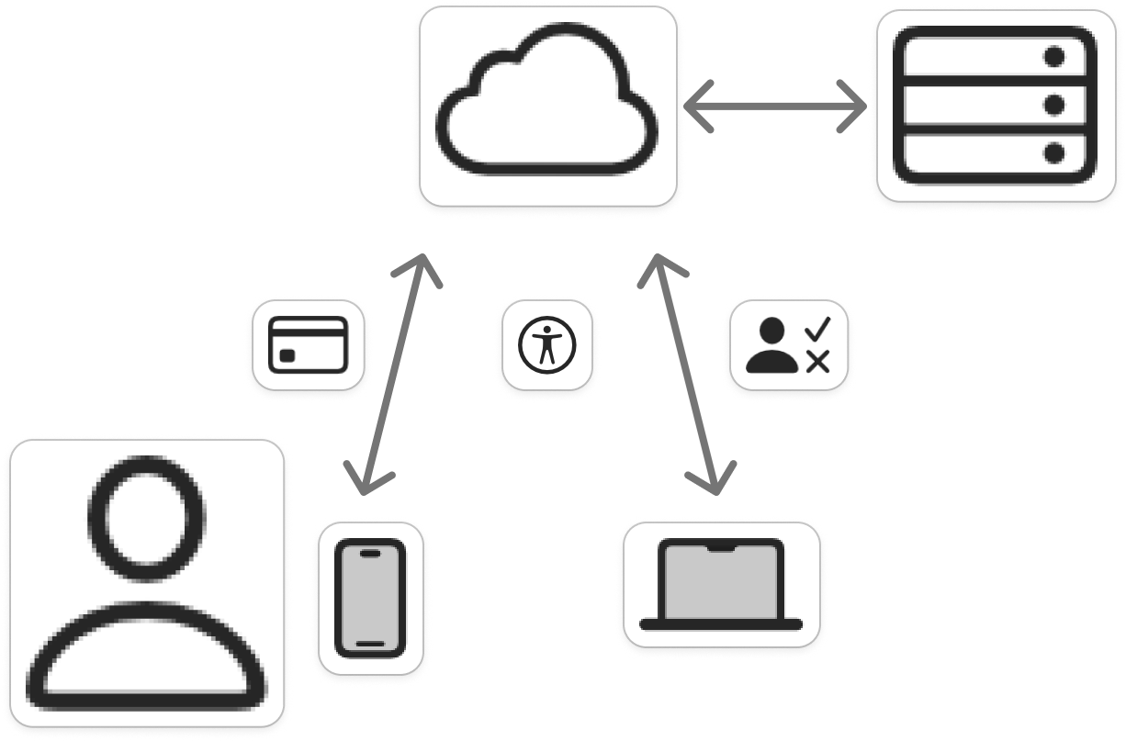
Figure 1. Business level view of Citizen Services Mobile Application
The envisioned Citizen Services solution enables residents to securely access and manage key municipal services through a unified mobile and web platform. Citizens will be able to submit permit applications, make bill payments, and track public works requests directly from their mobile devices, while municipal staff will access enhanced reporting and administrative tools via desktop browsers. All citizen transactions, requests, and status updates will be synchronized with existing legacy systems through a secure cloud integration layer. Data and service logs will be stored within a compliant government cloud environment to ensure security, accessibility, and continuity.

Business Goals
The section enumerates essential business goals for the solution
# | Description
BG-1 | Modernize the municipality’s current approach to citizen service delivery by consolidating fragmented service portals into a unified, mobile-first platform.
BG-2 | Improve operational efficiency and reduce administrative overhead through increased citizen self-service adoption and automation of routine transactions.
BG-3 | Enhance citizen satisfaction and engagement by providing a seamless, intuitive, and accessible mobile experience across iOS and Android devices.
BG-4 | Achieve measurable cost savings (target: $550K per year) by decreasing reliance on call centers and in-person interactions.
BG-5 | Strengthen data collection and analytics capabilities for better decision-making and performance measurement across departments.
BG-6 | Ensure compliance with government security, privacy, and accessibility standards (e.g., WCAG 2.1 AA, Auth0 SSO integration).
BG-7 | Enable scalable digital transformation by integrating with existing legacy backend systems (billing, permitting, public works) via secure APIs.

Major Features
The section enumerates solution major features.
# | Description
F-1 | Centralized transaction data storage and management on the cloud, enabling unified access to all municipal service records.
F-2 | Seamless integration with legacy backend systems via secure API gateway.
F-3 | Mobile-first design providing consistent and responsive user experience across iOS, Android, and web platforms.
F-4 | Secure authentication and access control through Single Sign-On (SSO) using the corporate Auth0 framework.
F-5 | Real-time tracking and notifications for service requests, permit applications, and bill payments.
F-6 | Integrated online payment system supporting multiple payment methods with full encryption compliance.
F-7 | Comprehensive administrative dashboard for municipal staff to manage requests, workflows, and performance analytics and create reports for analisys.
F-8 | Municipal staff should have access to requests, and instruments to accept or decline any request.

Use Case Model

Use Case Non-authenticated Citizen authentefication

View Context
The interaction outlined in the feature 4 happens between the Non-authenticated Citizen and service auth page

Representation
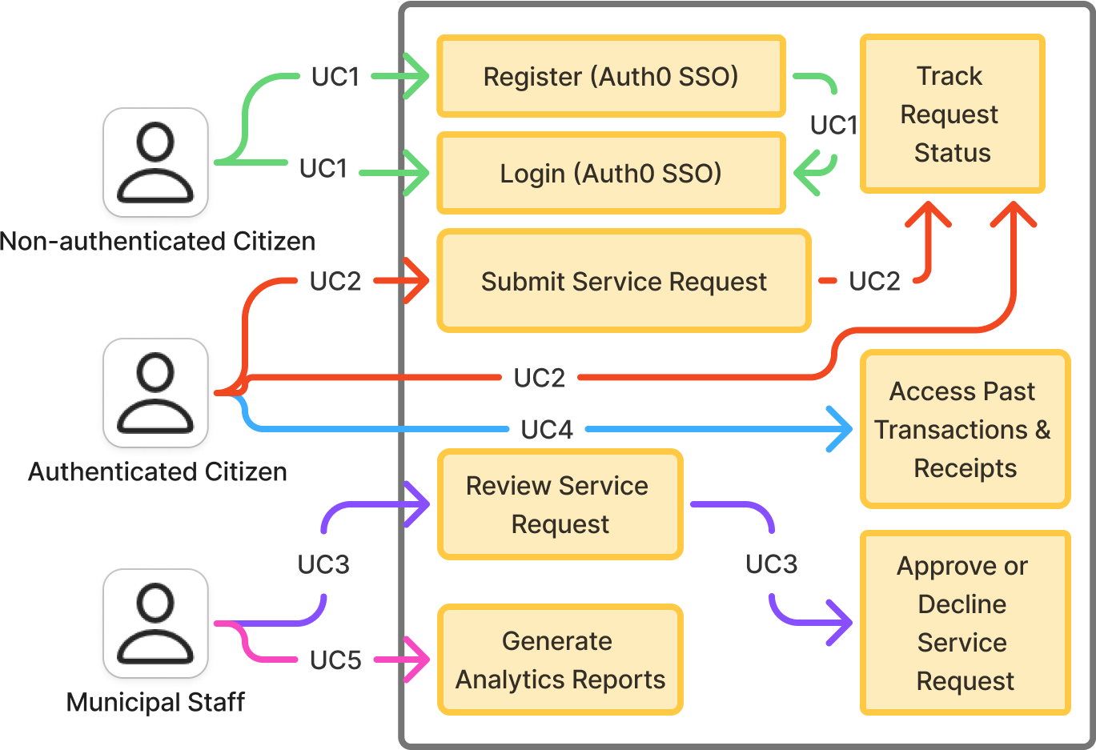
Figure 1. Non-authenticated Citizen authentefication
This view defines primary Use Cases for the feature 4.

Element Catalog
# | Name | Description
ACT-1 | Non-authenticated Citizen | User, which use our service for first time, or which was loged out
UC-1 | Citizen already have an account | User logs into the system.
UC-1 | Citizen don’t have an account | User register in service, and than logs into the system

Use Case Authenticated Citizen submit request

View Context
The interaction outlined in the feature 5 happens between the Authenticated Citizen and request service

Representation
Figure 2. Authenticated Citizen submit request
This view defines primary Use Cases for the feature 5.

Element Catalog
# | Name | Description
ACT-1 | Authenticated Citizen | User which successfully loged into our service
UC-2 | Citizen submit service request and track its status | User submit his request and can follow his status by system
UC-2 | Citizen track status of any request submitted by Citizen | User following status of all his own requests

Use Case Municipal Staff review citizen requests

View Context
The interaction outlined in the feature 8 happens between the Municipal Staff and user requests

Representation
Figure 3. Municipal Staff review citizen requests
This view defines primary Use Cases for the feature 8.

Element Catalog
# | Name | Description
ACT-1 | Municipal Staff | Staff which can manage citizen requests
UC-3 | Municipal Staff with proper competency can review, accept or deny citizen submitted requests | To make a proper conection with citizens, their submitted requests can be accepted or denied by Municipal staff

Use Case Authenticated Citizen can access past transactions and receipts

View Context
The interaction outlined in the feature 1 happens between the Authenticated Citizen and and cloud database

Representation
Figure 4. Authenticated Citizen can access past transactions and receipts
This view defines primary Use Cases for the feature 1.

Element Catalog
# | Name | Description
ACT-1 | Authenticated Citizen | User which successfully loged into our service
UC-4 | Citizen can access to past request and receipts | User can get information about any of his own past request or receipt

Use Case Municipal Staff get Analytics Reports

View Context
The interaction outlined in the feature 7 happens between the Authenticated Citizen and request service

Representation
Figure 5. Municipal Staff get Analytics Reports
This view defines primary Use Cases for the feature 7.

Element Catalog
# | Name | Description
ACT-1 | Municipal Staff | Staff which can manage citizen requests
UC-5 | Municipal Staff get Analytics Reports | Municipal staff can generate Analytics report for analisys. It can be not only about services but also about statistic

Design Constraints
The section lists the constraints accounted for in the designed solution. These can be of business, technical, resource, and other types.
# | Description
CONST-1 | A minimum of 1,000 simultaneous users must be supported under normal operating conditions to ensure scalability and adequate performance for high-volume citizen access.
CONST-2 | Time to market must be within 10-month, including all phases of design, development, testing, and deployment, to align with the fiscal budget and municipal service improvement goals.
CONST-3 | The application must fully comply with governmental security and data protection standards, including data encryption, secure authentication (SSO), and audit logging.
CONST-4 | The system must meet accessibility standards (WCAG 2.1 AA) to guarantee usability for all citizens, including those with disabilities.
CONST-5 | Integration with three legacy backend systems (Billing, Permitting, and Public Works) is mandatory for the initial release to ensure complete service continuity.
CONST-6 | Mobile apps must be native (iOS and Android 4+), and the administrative dashboard must be accessible through modern web browsers.
CONST-7 | All data backups and transaction logs must be stored in a compliant cloud storage environment to meet retention and recovery policy requirements.

Quality Attribute Scenarios
A Quality Attribute Scenario is an unambiguous and testable requirement for one or more Solution Quality Attributes such as Performance, Usability, Maintainability and others. The scenario consists of six parts: Source of Stimulus, Stimulus, Environment, Artifact, Response, testable and accurate Response Measure.
This section lists and prioritizes the scenarios pertinent to the designed solution.
# | Quality Attribute | Scenario | Business Priority | Related  To
QA-1 | Security  (credentials transport security) | At all times, the credentials entered by the user during login are transferred to the server over an encrypted, secure channel (HTTPS/TLS 1.3) without the possibility of interception or sniffing by a third party. | High | UC-1
QA-2 | Usability  (easiness of payment) | When logged in and navigated to the service page, no more than 3 clicks needed to start processing user request. | Medium | UC-2
QA-3 | Performance (system responsiveness) | Under normal operating load (up to 1,000 concurrent users), the system must return search results or service request status updates within 2 seconds. | High | UC-2, UC-3, UC-4
QA-4 | Availability (system uptime) | The production environment must maintain 99.5% uptime excluding planned maintenance, ensuring continuous citizen access to services. | High | UC-1, UC-2, UC-3, UC-4
QA-5 | Accessibility (WCAG 2.1 AA compliance) | All application interfaces must pass accessibility validation tools, ensuring that citizens with disabilities can perform all supported functions. | High | UC-1, UC-2, UC-4
QA-6 | Maintainability (code and configuration management) | All application components must be containerized and deployed using CI/CD pipelines, allowing bug fixes or feature updates to be released to production within 12 hours after approval. | Medium | UC-1, UC-2, UC-3, UC-4,  UC-5

Scenario: QA-1
Quality Attributes: Security
Business Priority: High
Related To: UC-1
Description: At all times, the credentials entered by the user during login are transferred to the server over an encrypted, secure channel (HTTPS/TLS 1.3) without the possibility of interception or sniffing by a third party.
Environment: Normal operation conditions
Source
Login Form

Artifact
Client-Server Channel

Response Measure
Traffic encrypted and protected from sniffing

Stimulus
Response
Enter and submit credentials
Credentials transferred to server
Environment: The system is online and accessible from outside

Solution Architecture
The section Solution Architecture is primary for the Architecture Vision document. It defines and reasons about the solution architecture design based on requirements and constraints identified in the section Architectural Drivers.

Big Picture
The section includes a list of architectural views covering the designed solution along with the context it runs in on the high level.

Solution Context

Intent
The view defines the primary solution components collaborating with the external systems and services. It is driven by the Business Case.

Representation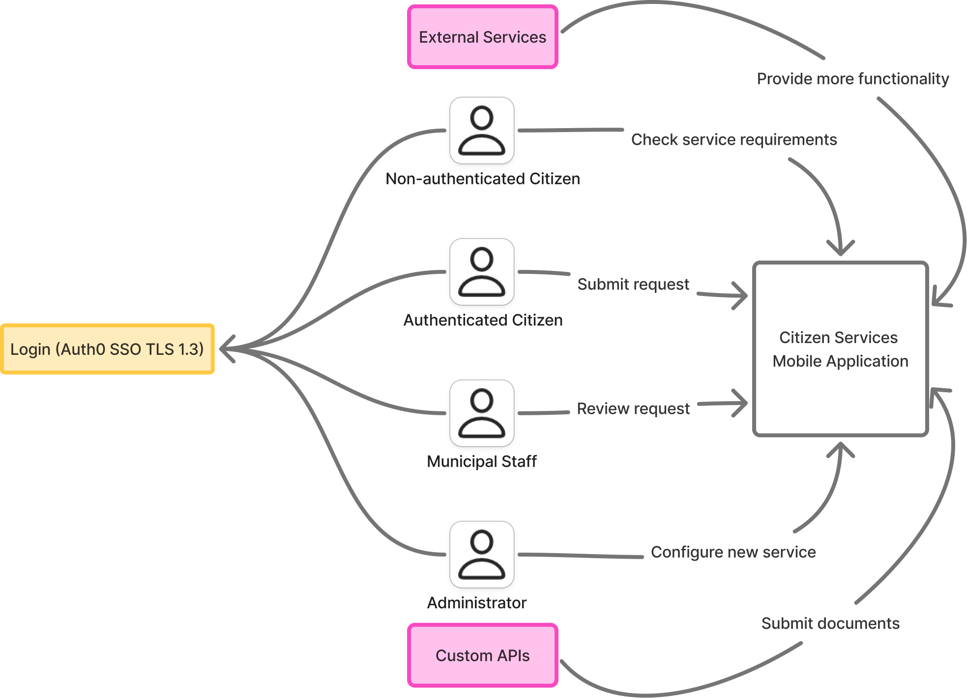

Figure 4. Solution Context diagram
The Citizen Services Mobile Application is a mobile-first platform enabling citizens to submit municipal service requests, upload documents, and track progress. Non-authenticated citizens can browse available services, while authenticated citizens log in via Auth0 SSO (TLS 1.3) to submit requests and receive updates. Municipal staff review, approve, and manage requests, and administrators configure services and workflows. The system integrates with legacy municipal systems through custom APIs and external services for secure document handling. Role-based access, encryption, and workflow orchestration ensure secure, efficient, and compliant service delivery.

Element Catalog
Table of annotated elements
Name | Description / Responsibilities
Citizen Services Mobile Application | Provides the mobile interface for citizens to browse services, submit requests, upload documents, and track status; communicates with backend APIs securely.
Auth0 SSO | Handles authentication and authorization for citizens and staff; enforces TLS 1.3 encryption and multi-factor authentication.
Non-Authenticated Citizen | Can browse available municipal services but cannot submit requests or access personal data.
Authenticated Citizen | Logs in via Auth0 SSO, submits service requests, uploads supporting documents, and tracks request status.
Municipal Staff Interface | Web or mobile portal used by municipal staff to review, approve, and process citizen requests; updates request status in backend systems.
Administrator Interface | Allows administrators to configure new services, manage workflows, and oversee integrations with external APIs and systems.
Custom APIs | Facilitates secure data exchange between the application backend and existing municipal systems (billing, permitting, public works).
External Services | Add possibility to use extra resources and access its data.

Solution Decomposition

Intent
The view defines the runtime decomposition of the server-side part of the solution. It is driven by the Citizen Services Mobile Application and the architecture best practices applicable to the cloud-based applications.

Context
The view context is defined by the view Solution Context where this section represents the decomposition of the system using the Containers view.

Representation
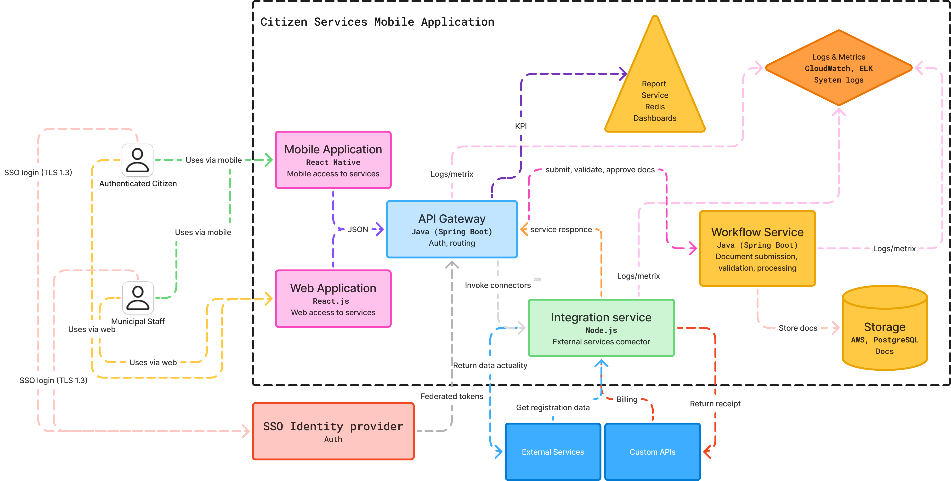
Figure 5. Cloud Solution Container view
The diagram illustrates the container-level architecture of the Citizen Services Platform. Users, including citizens and municipal staff, access the system through a Mobile Application (React Native) or a Web Application (React.js), both connecting to the central API Gateway (Java, Spring Boot) via secure REST/JSON communication. Authentication is handled by an external SSO Identity Provider using federated tokens over TLS 1.3, enabling Single Sign-On (SSO) for both citizens and staff.
The API Gateway manages routing, authorization, and orchestrates interactions between internal services: the Workflow Service (Java, Spring Boot) for document submission, validation, and processing; the Report Service (Java, Spring Boot) for generating dashboards and KPIs; and the Integration Service (Node.js) for connecting to external services, such as billing, registration databases, and other municipal systems.
Data is stored in the Relational Database (AWS RDS/PostgreSQL) for structured data and AWS S3 for documents, while Redis caches high-demand data for performance optimization. System logs and metrics are collected through CloudWatch and the ELK Stack, enabling monitoring, auditing, and operational insights.
External services, such as municipal legacy systems, billing platforms, and regulatory APIs, are accessed via the Integration Service, ensuring real-time data exchange and document validation. Citizens can submit, track, and approve documents via mobile, while municipal staff manage workflows and data through the web portal. The architecture ensures high scalability, security, and resilience, forming a secure and efficient citizen engagement ecosystem.

Element Catalog
Table of annotated elements
# | Description
Web Application (React.js) | Provides browser-based access for municipal staff and administrators. Responsible for workflow management, document submission and approval, dashboard visualization, and invoking external service connectors. Communicates with the API Gateway via REST/JSON.
Mobile Application (React Native) | Enables citizens to submit, track, and approve documents, view service statuses, and receive notifications from mobile devices. Connects to the API Gateway through secure REST endpoints with SSO authentication (TLS 1.3).
API Gateway (Java, Spring Boot) | Central routing and orchestration service that manages authentication, authorization, request validation, and directs incoming requests to appropriate backend services. Supports JSON/REST communication between clients and microservices.
Workflow Service (Java, Spring Boot) | Handles document submission, validation, and approval workflows. Processes citizen requests, manages service logic, and logs workflow events. Interacts with databases, storage, and integration services through the API Gateway.
Report Service (Java, Spring Boot) | Generates dashboards, KPIs, and operational reports for staff and citizens. Aggregates data from databases, Redis cache, and workflow services. Sends logs and metrics to CloudWatch/ELK for monitoring and analytics.
Integration Service (Node.js) | Connects the platform to external municipal and third-party services, including billing, registration, and regulatory APIs. Handles data transformation, synchronization, and ensures real-time updates of citizen requests.
Storage (AWS S3 / PostgreSQL) | PostgreSQL stores structured service and user data with multi-AZ replication for high availability. S3 stores unstructured data such as citizen-uploaded documents, images, and attachments.
CloudWatch / ELK | Collects system logs, performance metrics, and audit trails from all services and applications. Provides centralized monitoring, alerting, and visualization for operational oversight and troubleshooting.
Auth / SSO Identity Provider | Provides secure authentication and authorization using federated tokens (OIDC/SAML) and MFA. Ensures secure login for citizens and municipal staff across web and mobile applications.
External Services | Third-party municipal or regulatory systems (billing, registration, permits) accessed via the Integration Service. Provides real-time data exchange, document verification, and service updates.
Custom APIs | Give possibility to use external apis for billing and etc
Logs & Metrics | Operational data collected from all services and applications, sent to CloudWatch/ELK for monitoring, analysis, and auditing. Ensures observability and system reliability.

Design Concerns
The section lists the concerns defined for the solution.
# | Description
CONC-1 | Ensure high availability (≥99.9%) across all microservices and mobile/web clients.
CONC-2 | Maintain horizontal scalability to support peak loads of up to 5000 concurrent users.
CONC-3 | Enforce compliance with ISO 27001, GDPR, and governmental security protocols for data protection.
CONC-4 | Minimize latency for citizen requests and synchronization with external municipal and regulatory APIs.
CONC-5 | Simplify integration with heterogeneous legacy systems (billing, permitting, public works) and third-party services.

Development Technology Stack
The section includes a list of decisions on tech stack, frameworks, libs, tools, external services, etc.

Development Languages, Frameworks, and Libraries

Intent
The view lists the set of programming languages, frameworks, and libraries the solution implementation will depend on.

Context
The context is provided by the view Solution Context.

Element Catalog
Table of annotated elements
Name | Version | Description
Java (Spring Boot) | 17+ | Backend REST API framework for core microservices.
Node.js | 20+ | Used in the Integration Service for connecting to ERP, finance, and external regulatory APIs.
React.js | 18+ | Web application frontend for administrative portals.
React Native | 0.74+ | Mobile application framework for iOS and Android citizen-facing apps.
PostgreSQL (AWS RDS) | 15 | Relational database for structured service and user data; supports multi-AZ replication.
AWS S3 | N/A | Object storage for citizen-uploaded documents and unstructured data.
Redis | 7 | Caching high-demand data for fast microservice access.
RabbitMQ | 3.13 | Asynchronous messaging between microservices in an event-driven architecture.
Keycloak | 21.1+ | Provides Single Sign-On (SSO) and Multi-Factor Authentication (MFA) using OIDC/SAML protocols.
Azure AD | N/A | Alternative SSO/MFA provider for enterprise authentication.
Jenkins | 2.x+ | CI/CD automation for building, testing, and deploying containerized microservices.
AWS CloudWatch | N/A | Monitoring, logging, and alerting for metrics and system performance.

Development Tools

Intent
The view lists the set of tools the development team will rely upon in solution implementation.

Context
The context is provided by the view Solution Context.

Element Catalog
Table of annotated elements
Name | Version | Description and
Java (Spring Boot) | 17+ | Backend REST API framework for core microservices development and business logic.
Node.js | 20+ | Runtime for integration services connecting ERP, finance, and external APIs.
React.js | 18+ | Frontend framework for web administrative portals.
React Native | 0.74+ | Framework for building mobile apps for iOS and Android.
PostgreSQL (AWS RDS) | 15 | Relational database for structured service and user data with multi-AZ replication.
Docker | 24+ | Containerization platform for packaging microservices for consistent deployment.
IntelliJ IDEA | 2024.x | Primary IDE for Java and Spring Boot development.
Xcode | 15+ | IDE for building iOS applications with React Native and native components.
Keycloak | 21.1+ | Identity and access management system providing SSO and MFA using OIDC/SAML protocols.

External Integration Points

Intent
The view lists the set of programming languages, frameworks, and libraries the solution implementation will depend on.

Context
The context is provided by the view Solution Context.

Element Catalog
Name | Integration Type | Description
SSO/MFA Identity Provider (Keycloak / Azure AD) | OIDC / SAML 2.0 over HTTPS | Provides centralized Single Sign-On and Multi-Factor Authentication for citizens and municipal staff. Issues JWT tokens for secure access to backend services and API Gateway.
Municipal Legacy Systems (Billing, Permitting, Public Works) | REST/JSON over HTTPS | Exposes existing municipal service data for citizen requests. Integration Service handles real-time data exchange, submission, and retrieval of approvals or receipts.
Third-Party Services (Payment Gateways, Notifications, Geolocation APIs) | REST/JSON or Event-driven | Provides additional functionality such as secure payment processing, push notifications, and location-based services. Connected via Integration Service.
Storage Services (AWS S3 / PostgreSQL) | SQL / HTTPS | Stores structured service and user data in PostgreSQL and unstructured documents/images in S3. Supports multi-AZ replication for resilience and availability.
Custom APIs (Workflow, Reporting, Integration Services) | REST/JSON over HTTPS | Expose internal microservice functionality to web/mobile clients and external systems. Responsible for request validation, secure access, and orchestrating service workflows.

Implementation Roadmap
Implementation Roadmap defines the solution implementation road map including list of implementation deliverables, major milestones, effort estimates, and recommended team skillset, structure, and size.

Implementation Deliverables
The implemented solution will include the following parts as deliverables:
(list your deliverables in the table below)
Name | Refer to Requirements | Refer to Design
Application 1
Service 2
Mobile Client 3
Production Deployment 4

Implementation Milestones
The section proposes the major milestones to guide the solution implementation.
(decide and list main milestones for your project in the table below)
Milestone | Description | Outcomes
M0 | Project bootstrap | - Dev Team ramped up  - Dev and Testing Environment set up  - Project Skeleton built
M1 | Main application with web front-end development | - Alpha version of the web application  - Deployment to the staging
M2 | Development and stabilization of the web application, development of the deployment and monitoring procedures, release | - Release 1.0 of the application prepared and stable  - DevOps framework functional  - Release 1.0 goes to production

Estimate
The Estimate section provides the estimates for the solution implementation based on the proposed architecture and selected estimation methodology.

Assumptions and Limitations
This section describes the known limitations imposed by selected platform, technology, hardware, operating system, third party components, etc. which might affect implementation effort and schedule estimates.
(Describe assumptions and possible limitations that could affect delivery timelines in the table below)
# | Description | Responsible
A1 | Assumption 1 | <Client Name>
A2 | Assumption 2 | SoftServe Team
L1 | Limitation 1 | <Third Party Name>

Estimate
The Estimate section provides effort and, optionally, schedule estimates for the implementation based on the architecture proposed in this Vision document using the WBS approach.
(list delivery items and estimation for these items to be ready)
# | Item | Complexity | Min Effort | Max Effort
Total:

Team
The Team section outlines the proposed team skillset and structure based on the proposed technology stack and estimates.

Team Skillset
The section defines skills required from the different team member roles to implement the solution.
(describe team roles and required skillsets for these roles)
Role | Skillset
Business Analyst | - Business domain 1  - Business domain 2
Backend Developer | - Programming Language 1  - Technology 2  - Framework 3  - Tool 4  - Standard 5
UI Developer | - Programming Language 1  - Technology 2  - Framework 3  - Tool 4  - Standard 5
DevOps Engineer | - Programming Language 1  - Technology 2  - Framework 3  - Tool 4  - Standard 5

Team Structure
The section proposes a team/sub-team structure and work allocation for the implementation phase.
(describe teams and their responsibilities)

Core Team
The core team is responsible for:
- Development of <Component 1>
- Development of <Component 2>
- Support of <Application 1>

Role | Responsibility | Count | FTE
Project Manager | - Project management (coordinate the team, status reporting, communications with the Client team)  - Gap analysis | 1 | 0.5
Business Analyst | - Business analysis  - Business requirements specification  - Software requirements specification | 1 | 1.0
Solutions Architect | - System analysis and design  - System requirements specification | 1 | 0.2
Technical Leader | - Technical leadership and communication  - SCRUM Master  - Code Reviews  - Backend implementation | 1 | 1.0
Sr. Backend Developer | - Technical communication  - Code reviews  - Backend implementation | 2 | 1.0
Jr. Backend Developer | - Backend implementation | 3 | 1.0
Int. UI Developer | - Web frontend design and implementation  - UX prototyping | 3 | 1.0

DevOps Team
The DevOps team is responsible for:
- Configuration of <Environment 1>
- Configuration of <Environment 2>
- Deployment and runtime monitoring of <Application 1>

Role | Responsibility | Count | FTE
DevOps Architect | - Operations analysis and design | 1 | 0.2
Int. DevOps Engineer | - System deployment  - Environment setup  - Production operations support | 3 | 1.0

